1. What are three conclusions we can make about Kickstarter campaigns given the provided data?
   1. Cancelled rate stays fairly consistent regardless of month or year – limited range or dispersion
   2. Most successful months are Mar, May, June and July (late spring and summer)
   3. Most successful category is music and sub-category is documentary. The successful rate vs. failed rate is more than 4 to 1.
2. What are some of the limitations of this dataset?
   1. Not formal statistical analysis has been performed (ANOVA analysis for example) to determine p-value and variable relationship/correlation.
   2. Not all live data is present and/or perhaps some of the live data has been classified incorrectly as one of the other categories.
   3. Not all of the potential projects/ideas are in this file.
3. What are some other possible tables/graphs that we could create?
   1. Splitting the data by year to determine if there is a trend – earlier years vs. later years.
   2. Understand the failures better by analyzing the theater data – successes, failures, by year or by month
   3. Perform analysis on potential projects vs. what actually has happened. For example, how many documentary projects are in the pipeline vs. how many theatre projects are in the pipeline
   4. Perform more analysis on the funders and what’s driving higher or lower averages amongst that group

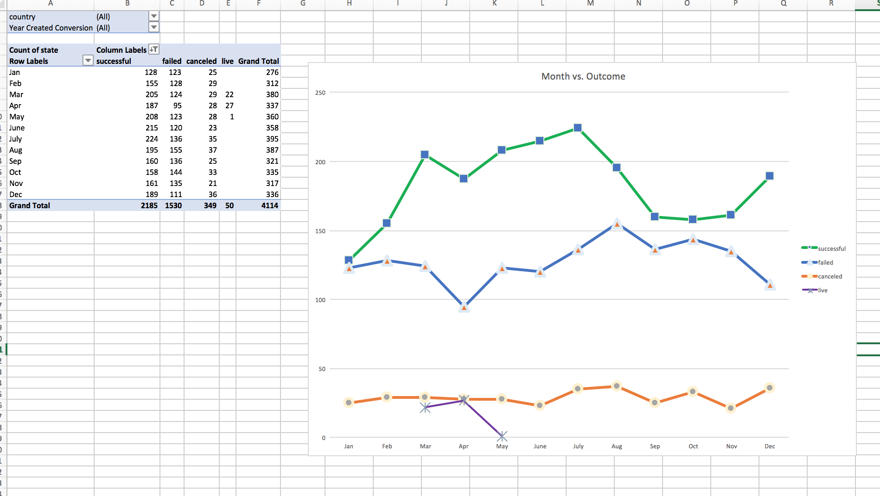

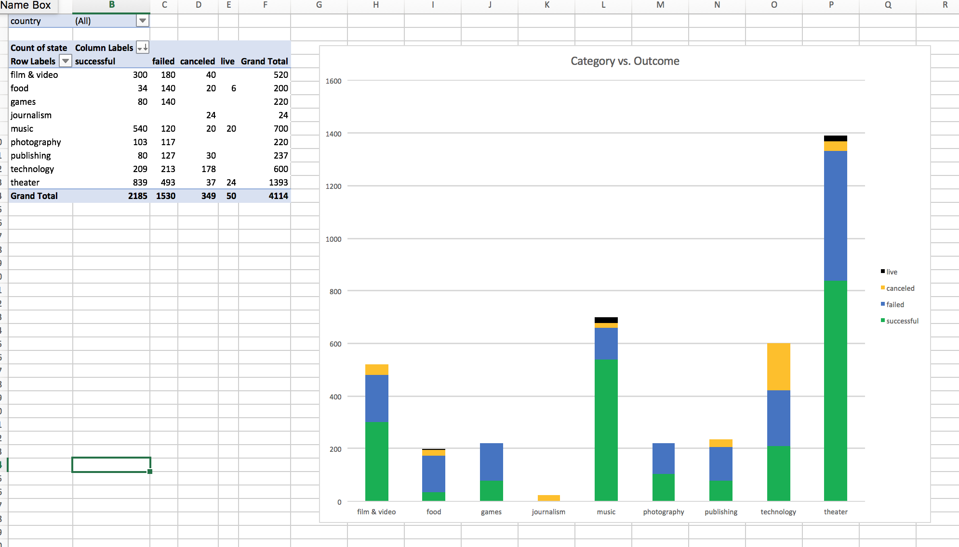

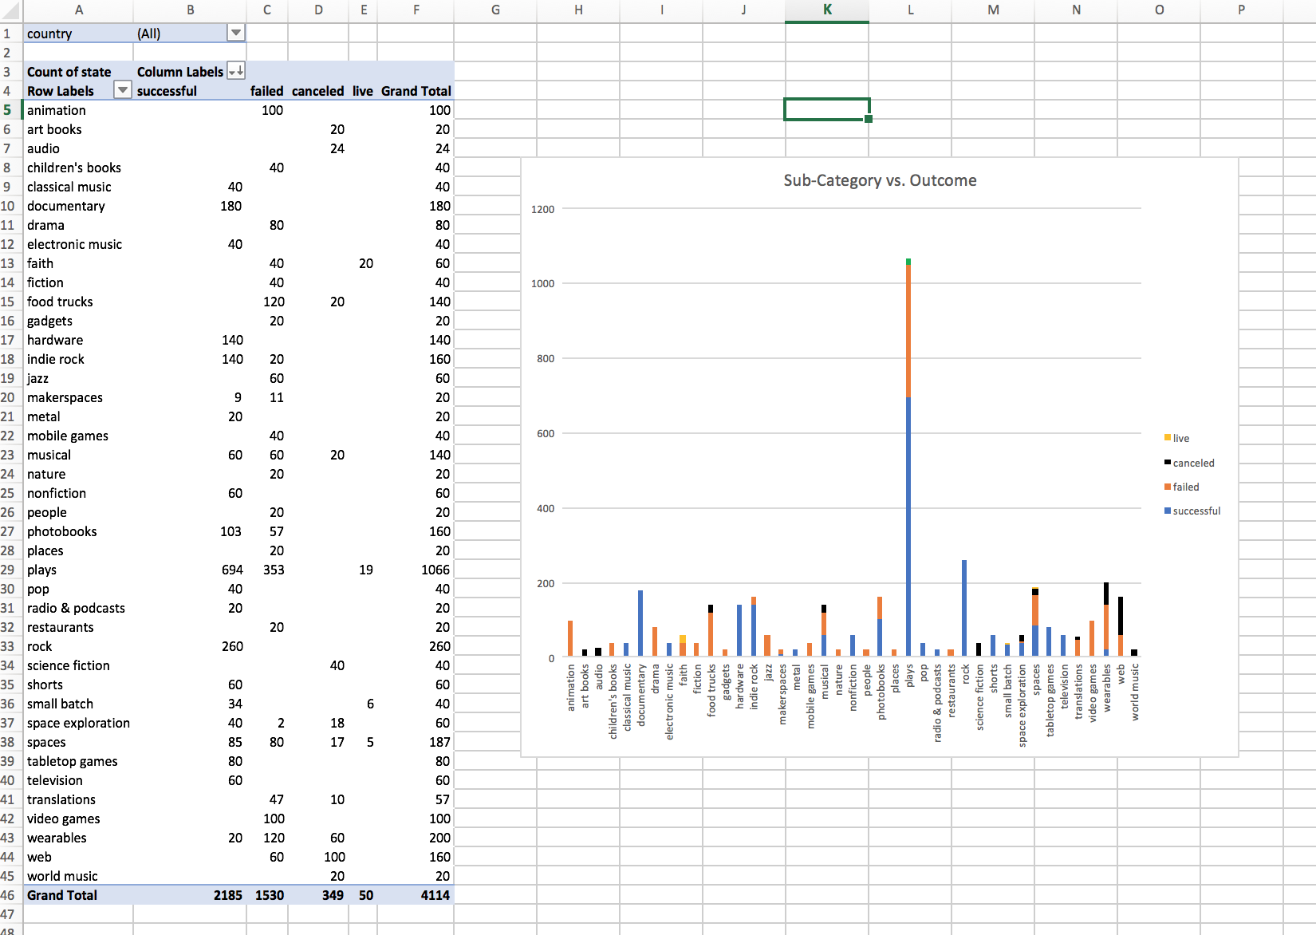

Bonus Assignment



